Chinese drywall update
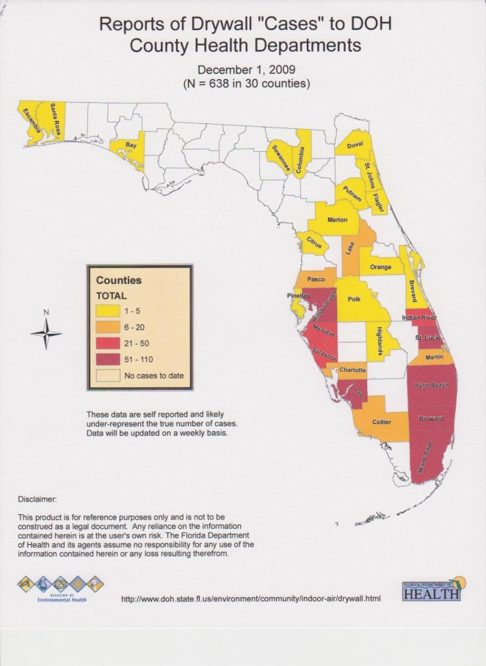
Newsflash! According to Channel 13 News… “In Central Florida 1 to 5 cases each have been reported in Orange, Polk, Brevard, Flagler and Marion County. In Lake County, officials have received 6 to 20 reports of the tainted drywall.” CPSC stats as of December 3, 2009, lists 1522 “drywall incidences” in Florida. The next 2 closest states are Louisiana with 417 and Virginia with 86. Comforting huh? One friend of mine, Robert Brown found it in Celebration. Another friend of mine, Thomas Battoe found it in Seminole County. Kelvin Eder built a house with it in Lake County. We have found it in Osceola County. Comforting huh? Want some more comfort…
It’s not all Chinese!
It has been reported that American manufacturer’s have used the same processes to manufacture the same reactive drywall commonly known as “Chinese drywall”. This has been confirmed to me by friends that have identified conditions consistent with Chinese drywall yet exhibited American nomenclature.

Despite some claims that your home inspector is responsible for finding or identifying “Chinese” drywall during your inspection, I respectfully say “NOT”. For one, there is no current federally recognized protocol for the inspection nor the testing of “Chinese” drywall. Also, it is very possible that just one or even a few boards exist but not the entire house. Thirdly, the physical manifestations may be undetectable at the time of your inspection because the triggers that amplify those manifestations were not set in motion. Therefore, it is unreasonable and may even be impossible for a home inspector to positively identify the presence of any “Chinese” drywall in a dwelling.

Let me make some things clear. The age of your home does not determine that reactive “Chinese” drywall exists. The term reactive is more accurate than Chinese as we learn more about this problem. “Chinese” is analogous to “Coke” or “Kleenex” and quite understandable because of the way this drama is unfolding. “Reactive” simply refers that the smell and corrosion are triggered or are reacting to certain conditions like heat and humidity. Hello Florida. In some houses like the one we saw in Clermont, FL, the weather conditions were such that heat and humidity were low and the AC system was installed quickly thereby limiting the obvious and sometimes widespread evidences associated with other houses where these conditions did not exist. Think about this…summer time…hurricane season…no power…high heat and humidity…reactive drywall, oooooh. Count on this problem not disappearing like your Christmas bonus anytime real soon.

One of the physical manifestations we as home inspectors look for is nomenclature or the names “Tianjen” or “China” stamped on the back side of the drywall. In an existing home, this advantage is not necessarily accessible. Most of the drywall in the attic that offers us a chance of directly observing these stamps is buried in insulation. Now, even if we were to expose a portion or portions of ceiling drywall above the living area or that insulation was absent still does not exclude the possibility of Chinese drywall elsewhere in the house. So…since removing one side of the drywall throughout the entire house could get you shot, this is not a practical solution during a home inspection.

Additionally, the time it would take to “inspect” (term used loosely) for reactive drywall, write an indication report, sample (destructive testing) and obtain test results from a lab would in most cases far exceed a buyer’s due diligence timeline.

Now from what I understand, if a house was built before 2004 only 2 indicators need be present to warrant further investigation. If the house was built after 2004, 3 indicators are necessary. Hypothetically, should these indicators all exist in a home you are interested in purchasing, proper testing could easily absorb $100,000 from your wallet. That will get you one heck of a report. If the report is negative, you’re only out say 100G’s. If the report is positive for reactive drywall, now you will need to go back and remove ALL the drywall, ALL the wiring, the AC units and any other affected metal components. Then…you can put it all back together. That would be one heck of house. This ain’t Graceland nor the White House. Be prepared to dump a truck load of money or…count your blessings (all 400 of them you spent hiring a professional home inspector) and simply move on my investor friend.

In summary, home inspectors may be able to “screen” for the physical manifestations of high sulphur content (reactive symptoms) drywall but can in no way be expected to positively identify the presence OR the absence of such a product in a simple home inspection. Call us with questions or concerns, 407.678.HOME or jon@inspectagator.com. If we all stick together, nobody gets burned! Sie sie!

